Cross Platform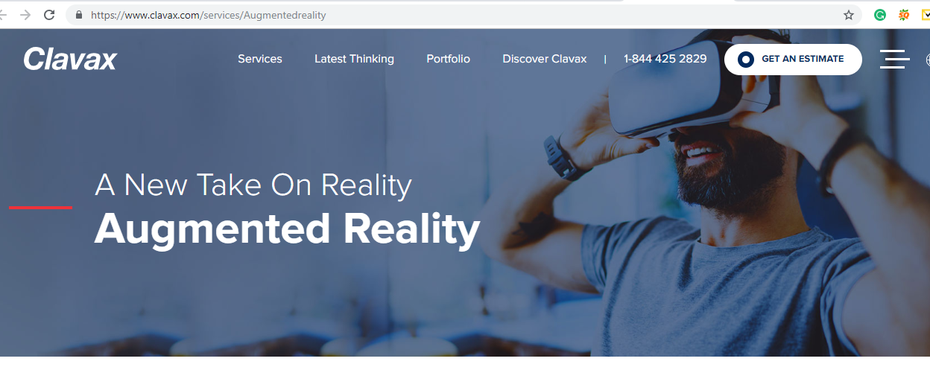

**Allows Users to Enjoy App on Any Device**

**Next>>**

With the increase use of the smartphone in the industry, businesses need technologies that offer “one-code-fits-all” facility. Cross-platform application development is often a good way to achieve this requirement. We at Nunc Systems develop mobile applications which run on all major platforms such as iOS, Android, Windows and save your time & cost.

Next>>

Managing entire Project Lifecycle and delivering amazing apps

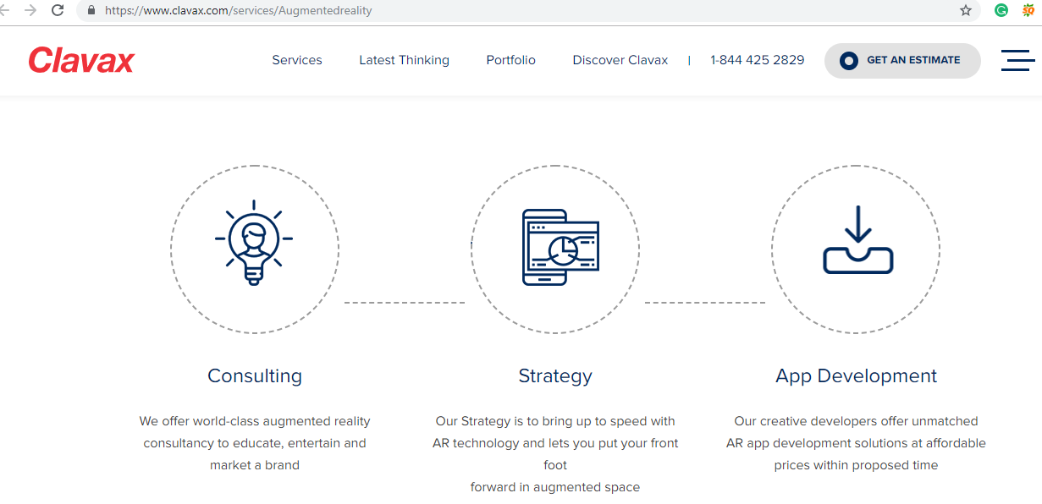

**Consulting**

We offer top-class consultancy to educate, entertain and market a brand

**Strategy**

Our strategy experts help in making an effective strategy for the growth of your mobile business.

**App Development**

Our expert team will make a striking design and user experience within proposed time

**Tools and Technologies**

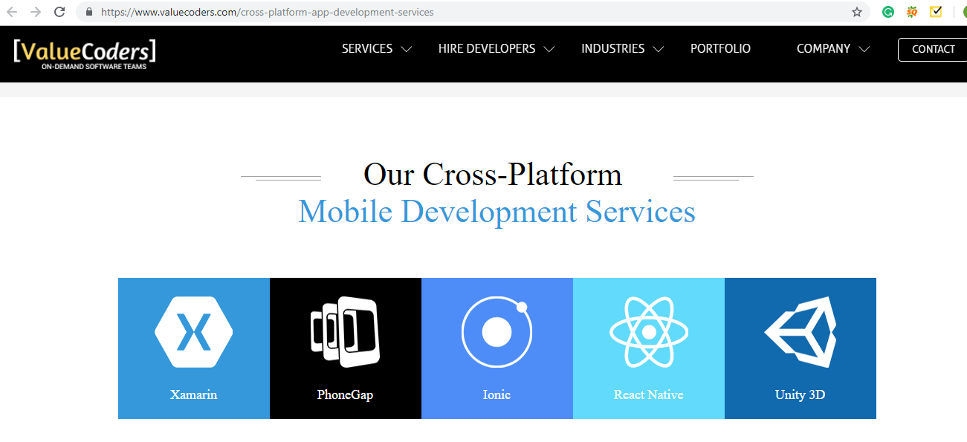

Next>> Get a Quote

